* Gayatri Pandit

Cloud (AWS) Week 1 Task

**TASK 1: DEPLOY APPLICATION IN MONOLITHIC AND MICROSERVICES ARCHITECTURE.**

* For Monolithic: 1 EC2 instance, deploy WordPress and MySQL on the same instance.

Create a welcome page in WordPress that will be the homepage.

**STEP 1: Create an EC2 Instance on AWS**

Navigate to the Amazon EC2 Instance service in the AWS Management Console and click on Launch. Enter a unique name for your EC2 Instance (EC2 Instance name must be globally unique across all AWS accounts).

**STEP 2: Enabling and Configuring the EC2 Instance**

- Choose the "Ubuntu" AMI.

- Select the "t2.micro" instance type for both instances.

- In the security group settings, create a new security group or use an existing one.

**Review and Launch the Instance.**

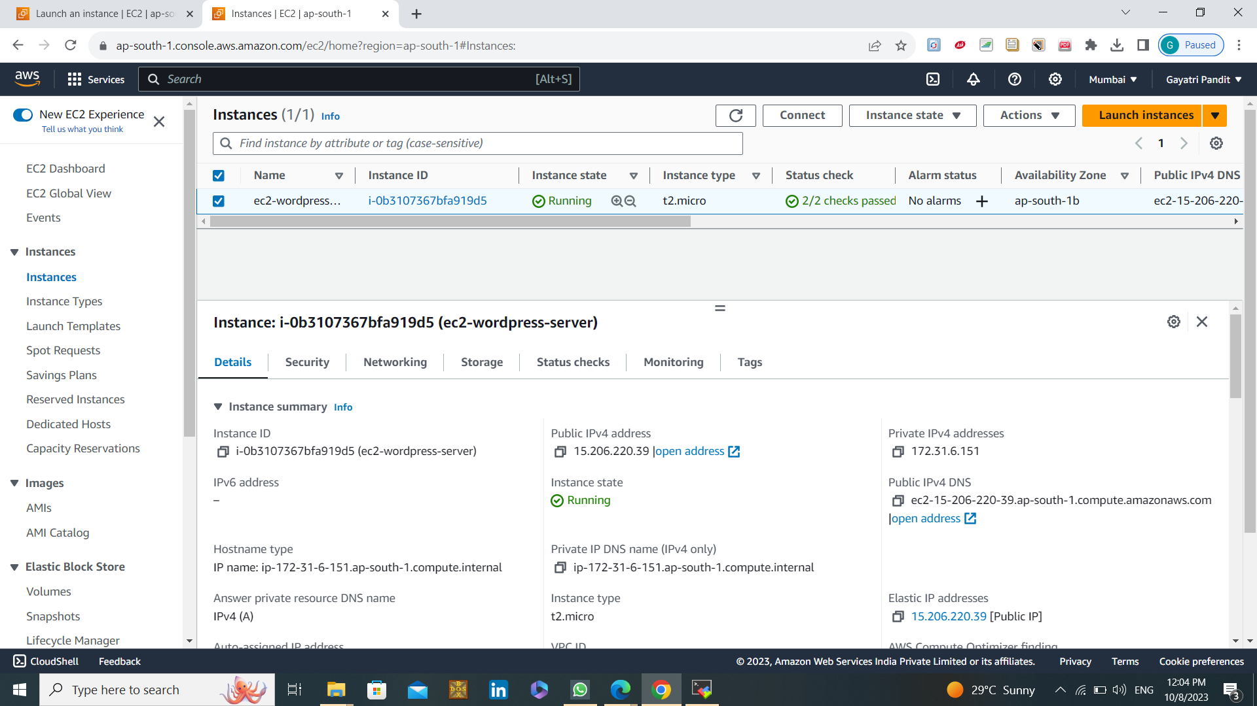

**STEP 3: Access the EC2 Instance:**

Once the instance is running, connect to it using SSH.

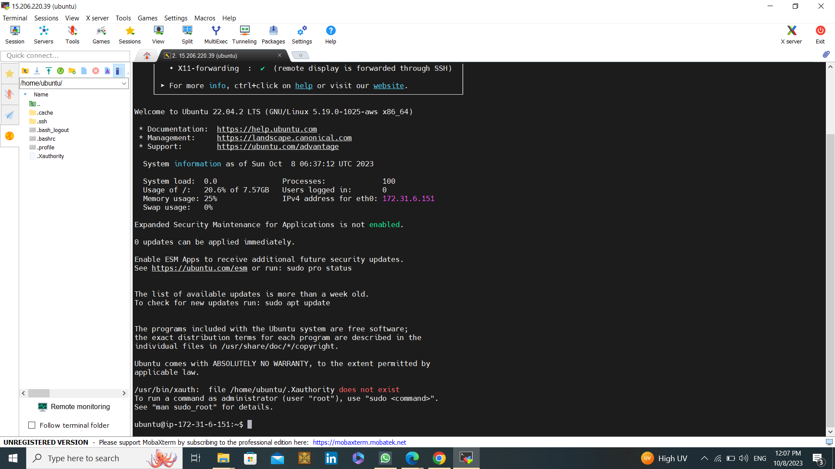

**STEP 4: Install Apache web server on my instance:**

**#sudo apt install apache2**

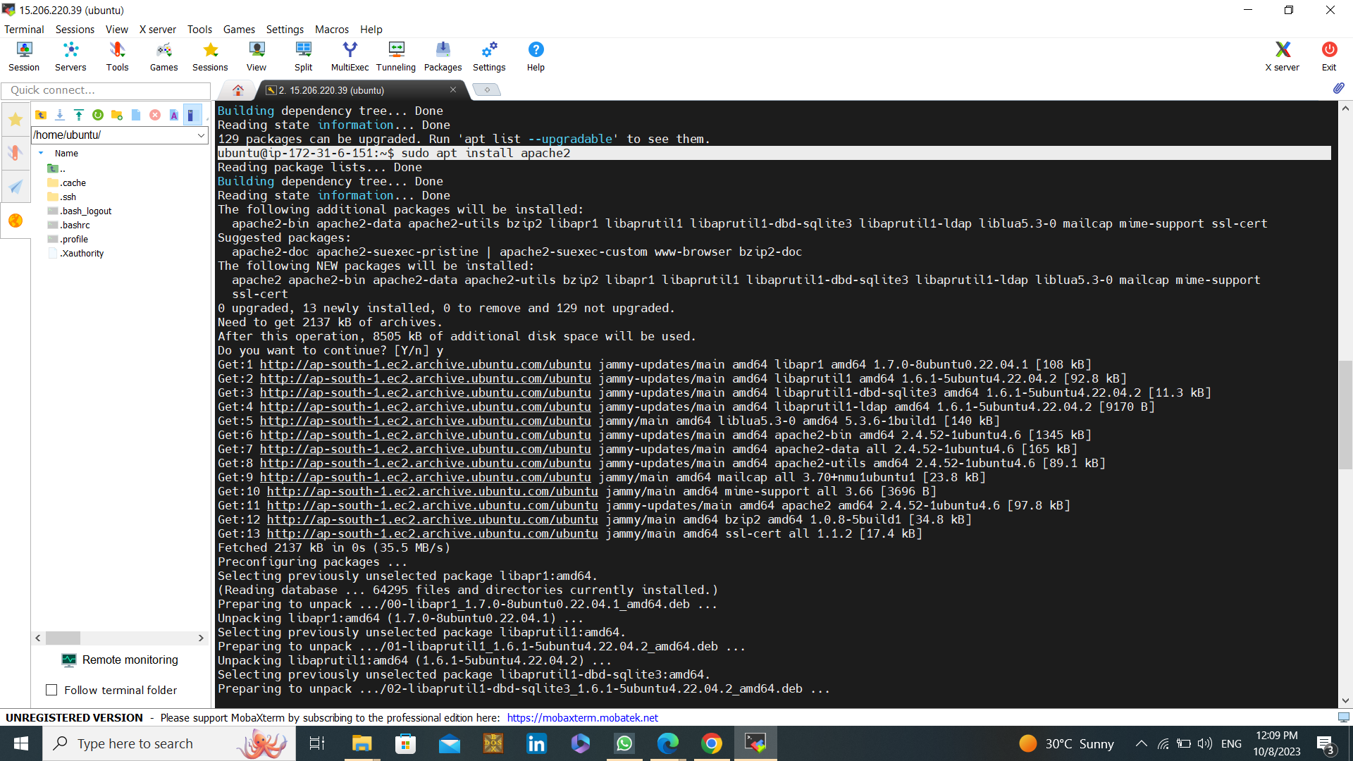

If you have to cross check your web server is running or not do http://YourIPV4 in a new tab and enter:

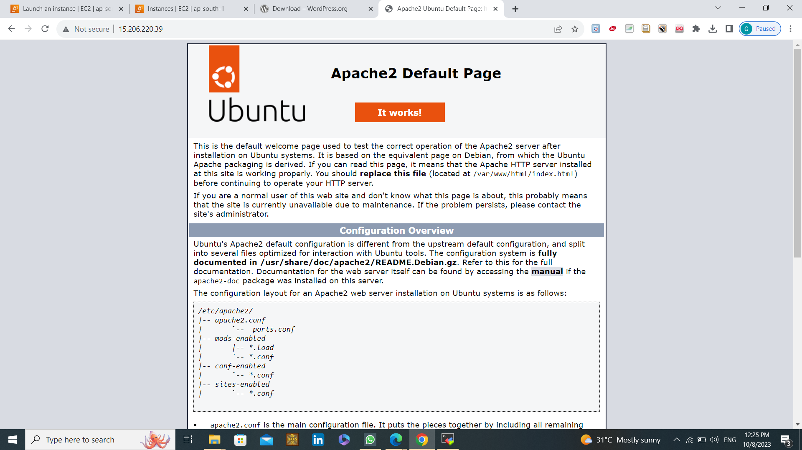

If you see a page like this its means your apache is running and install successfully.

**STEP 5: Installing MySQL:**

**#sudo apt install mysql-server**

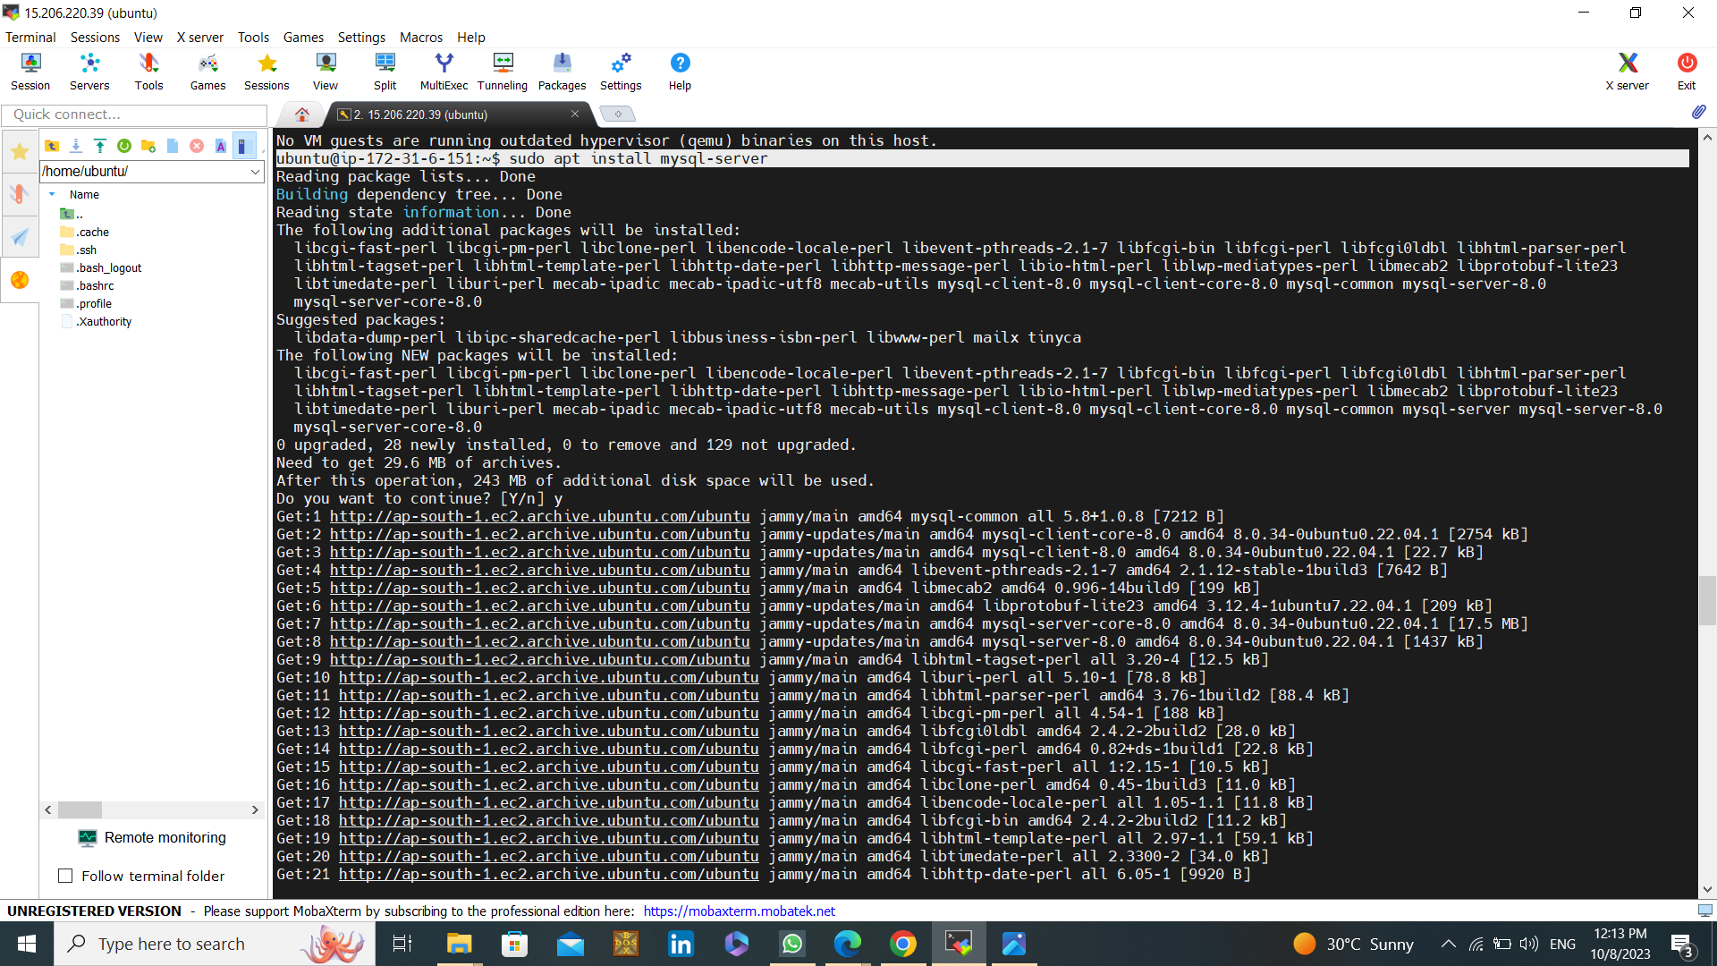

During installation, you'll be prompted to set a MySQL root password, Change the authentication plugin to following commands:

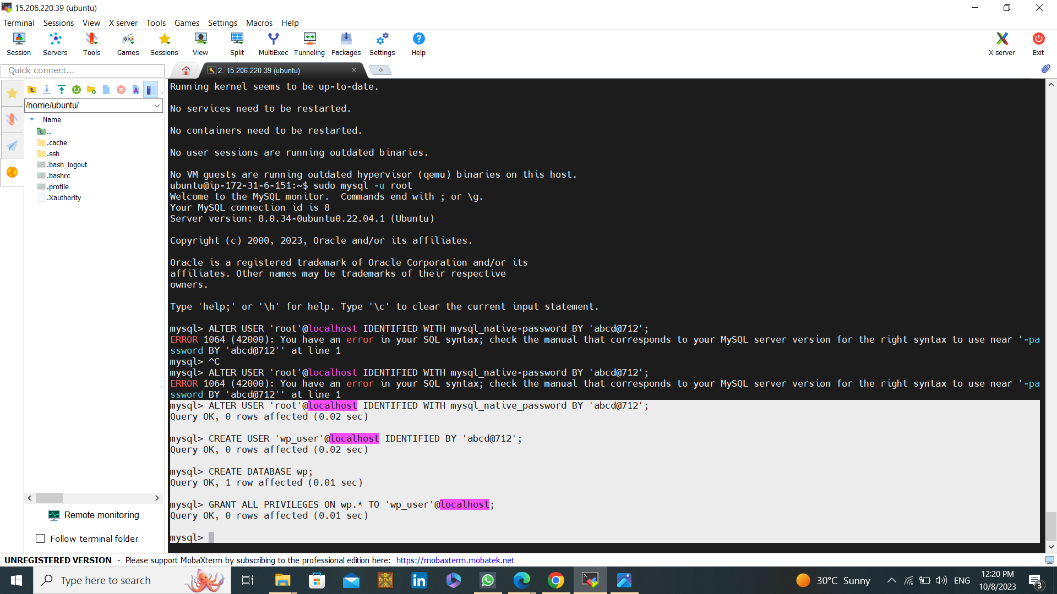

* Now configuration of MySQL server to login : **#sudo mysql -u root**
* **#ALTER USER 'root'@localhost IDENTIFIED WITH mysql_native_password BY 'YourPassword;** (Use a strong Password that harder to guess)
* **#After that create a new user : CREATE USER 'wp_user'@localhost IDENTIFIED BY 'YourPassword’;**
* Create a database : **#CREATE DATABASE wp;**
* Assign all the privileges, use : **#GRANT ALL PRIVILEGES ON wp.* TO 'wp_user'@localhost;**

**STEP 6 : Installing WordPress:**

* Copy the download link from: [wordpress.org](<https://wordpress.org/download/>)
* Come to the tmp directory: #**cd /tmp**
* Download the WordPress file, use **#wget(https://wordpress.org/latest.tar.gz)**

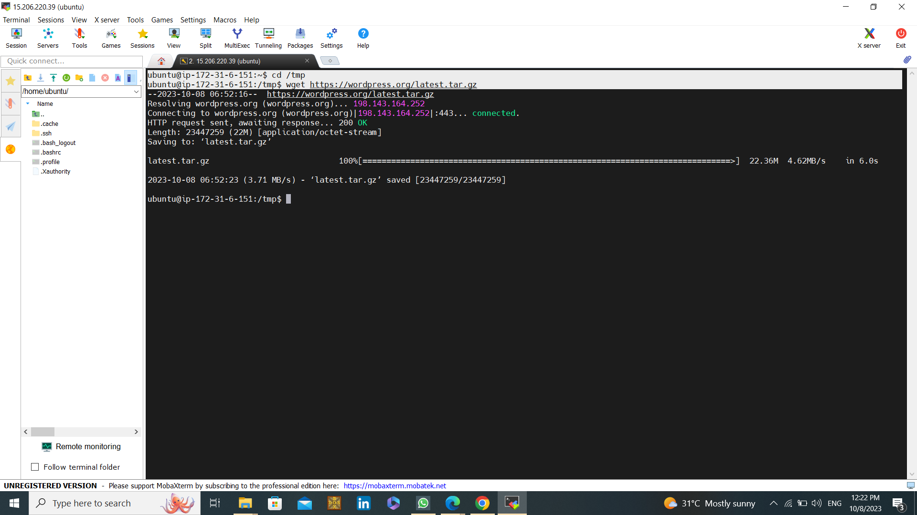

* unzip the folder use command : **#tar -xvf latest.tar.gz**

WordPress is installed successfully:

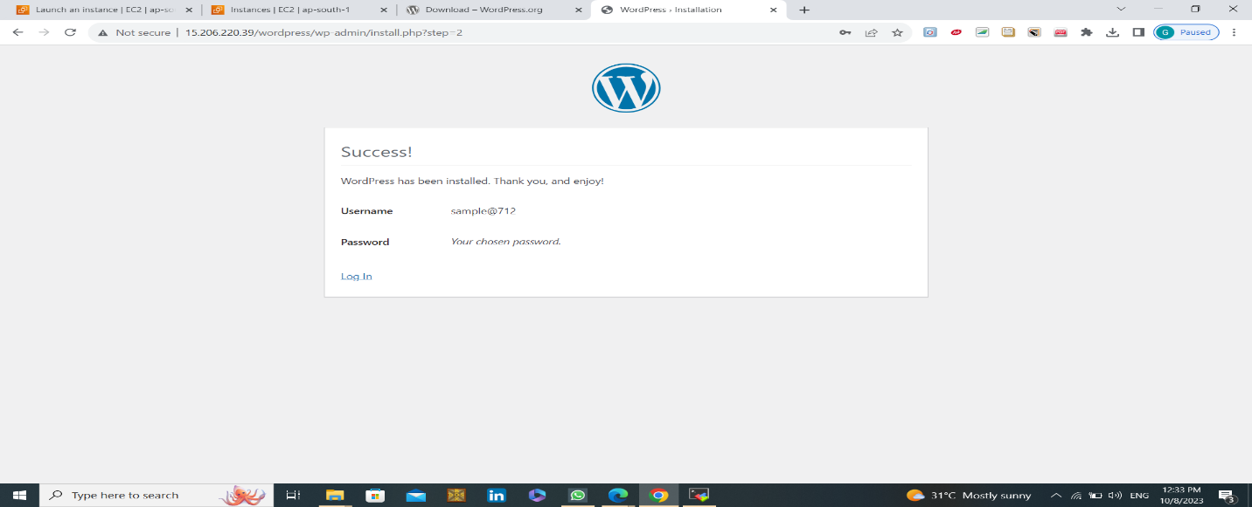

**STEP 6: Log into WordPress Admin:**

Access your WordPress dashboard by going to your website's URL followed by "/wp-admin" (e.g., IPV4/wp- admin). Log in using your credentials.

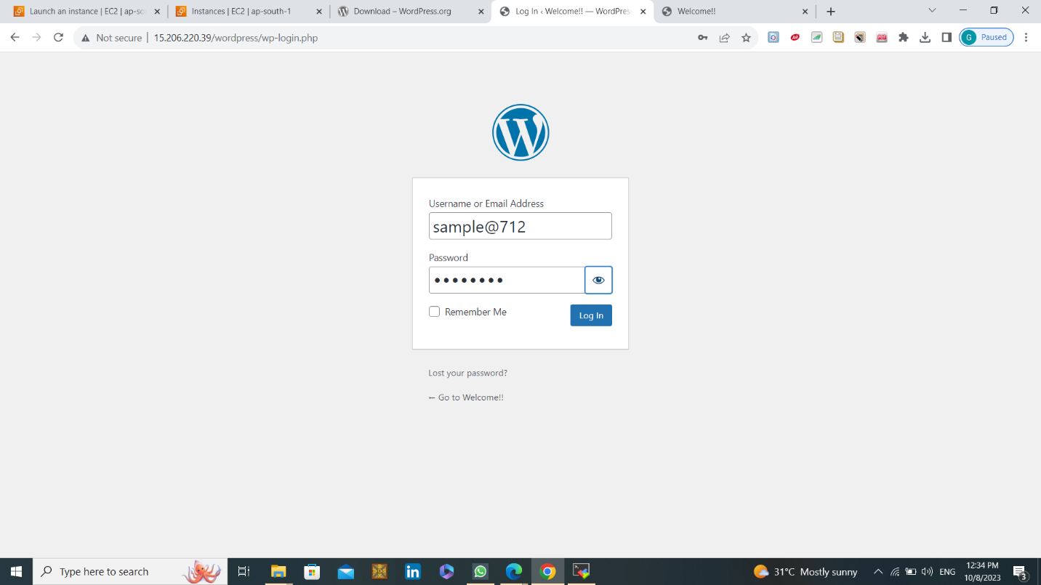

WordPress is installed on your EC2 instance:

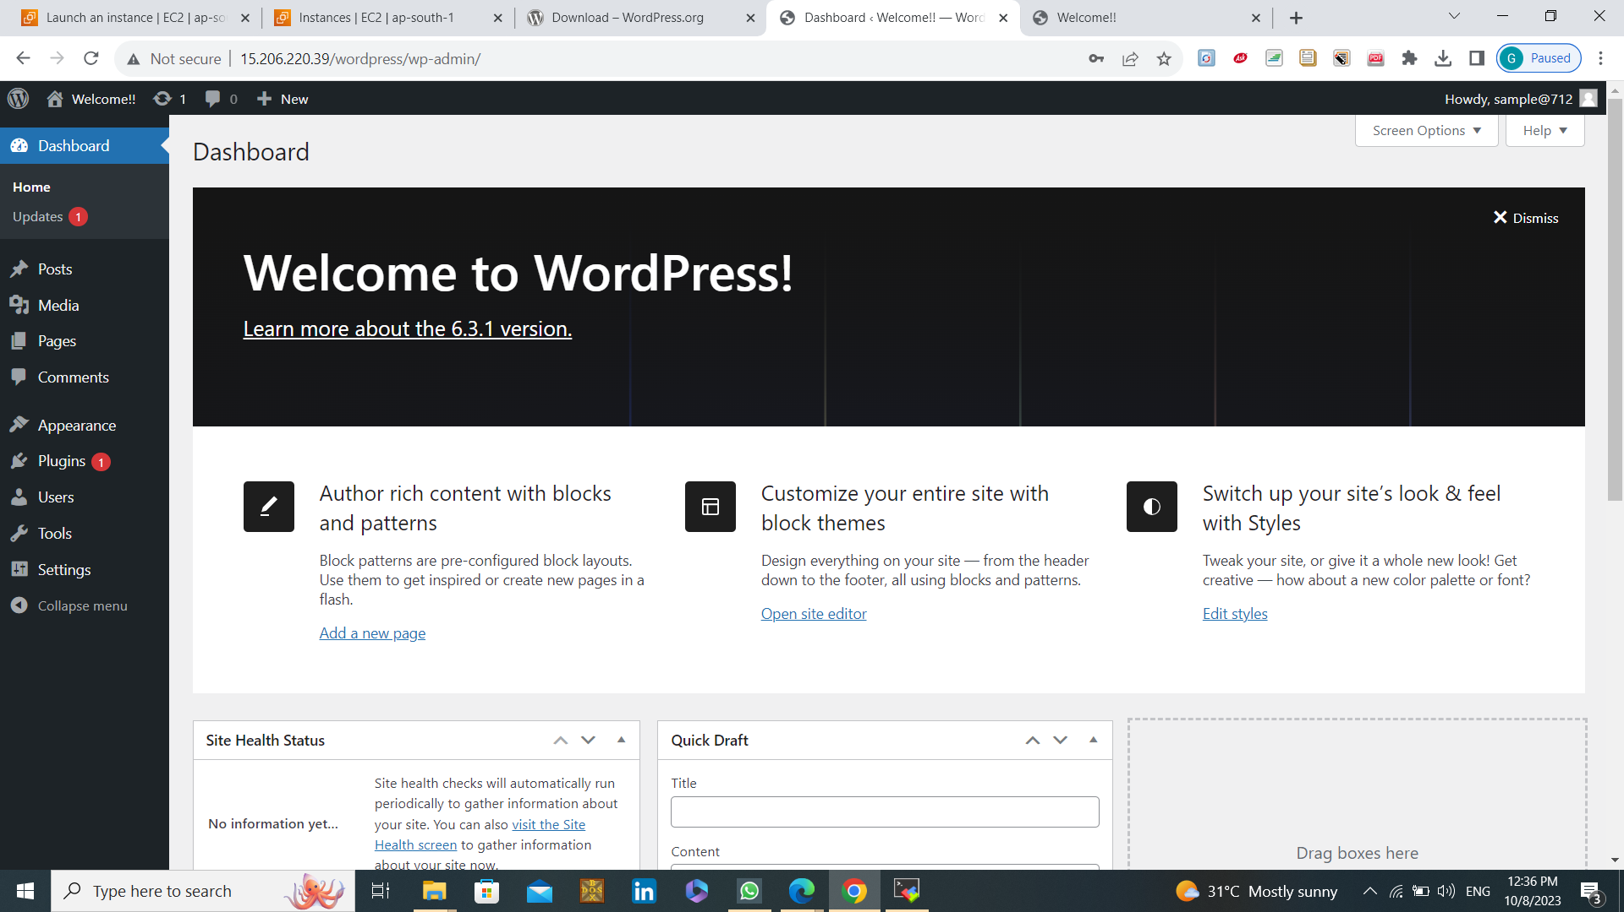

**STEP 7: Create a New Page:**

* In the WordPress dashboard, go to "Pages" and click on "Add New" to create a new page.-
* Add a Title: Enter a title for your welcome page. For example, you can use "Welcome to Our Website."

**STEP 8: Publish the Page:**

* Click the "Publish" button on the right side of the page editor to make your welcome page live.

**STEP 9: Set as Homepage:**

To do this, go to "Settings" > Reading" and choose "A static page" under "Front page displays." Select the welcome page you created from the drop-down menu.

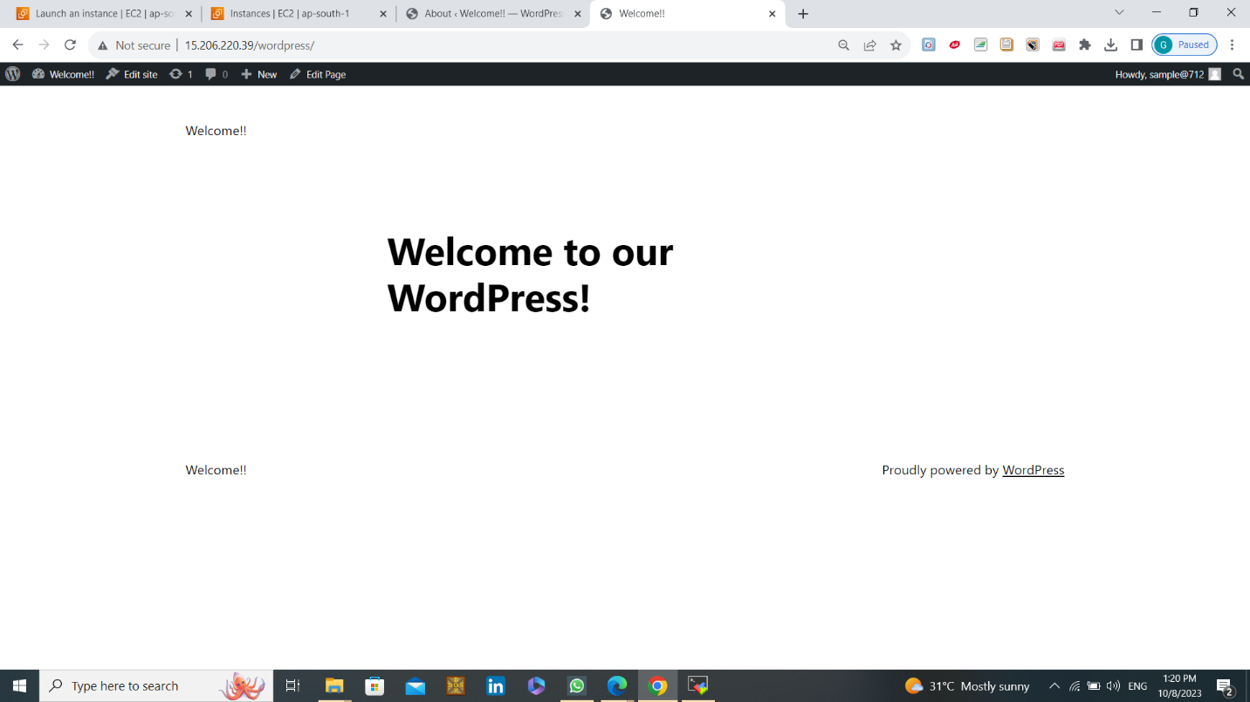

**That's it! I am deploying a simple welcome page in WordPress on AWS EC2 instance successfully. You can further enhance and customize it by exploring various plugins and themes to meet your website's specific needs.**

* **MICROSERVICE:- 2 EC2 INSTANCES, ONE FOR WORDPRESS AND ONE FOR MYSQL**

**STEP 1: Create an 2 EC2 Instance on AWS**

* 1 instance For WordPress and 1 instance for MySQL.
* Choose the "Ubuntu" AMI.
* Select the "t2.micro" instance type for both instances.

1. I have created wordpress-1 to deploy the WordPress application.
2. I have created mysql-1 instance to deploy the MySQL server.

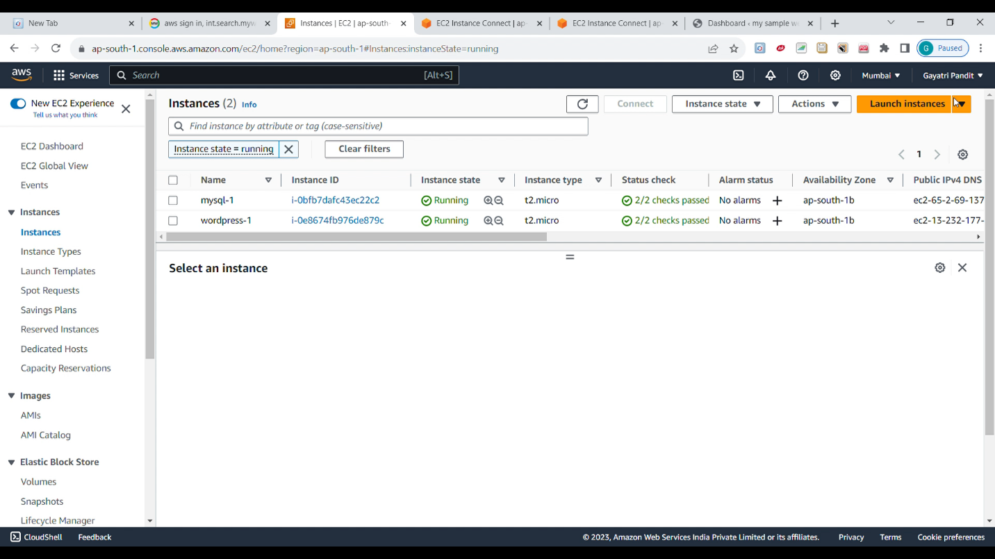

**STEP 2: Deploying Wordpress in the created EC2 instance i.e wordpress-1**

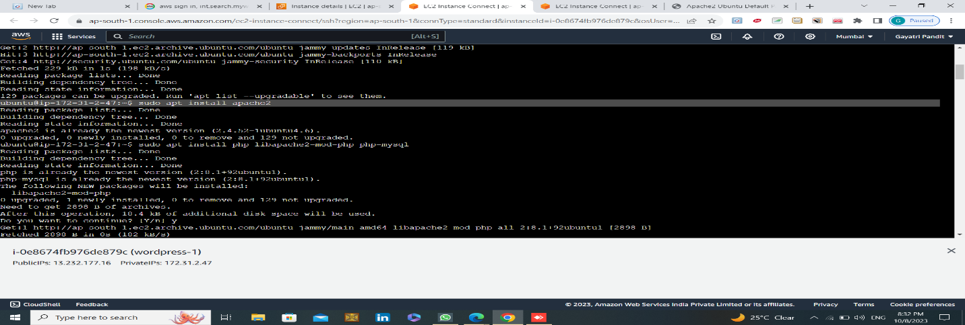

* By browsing the Public IP we can load the web page of the apache2:

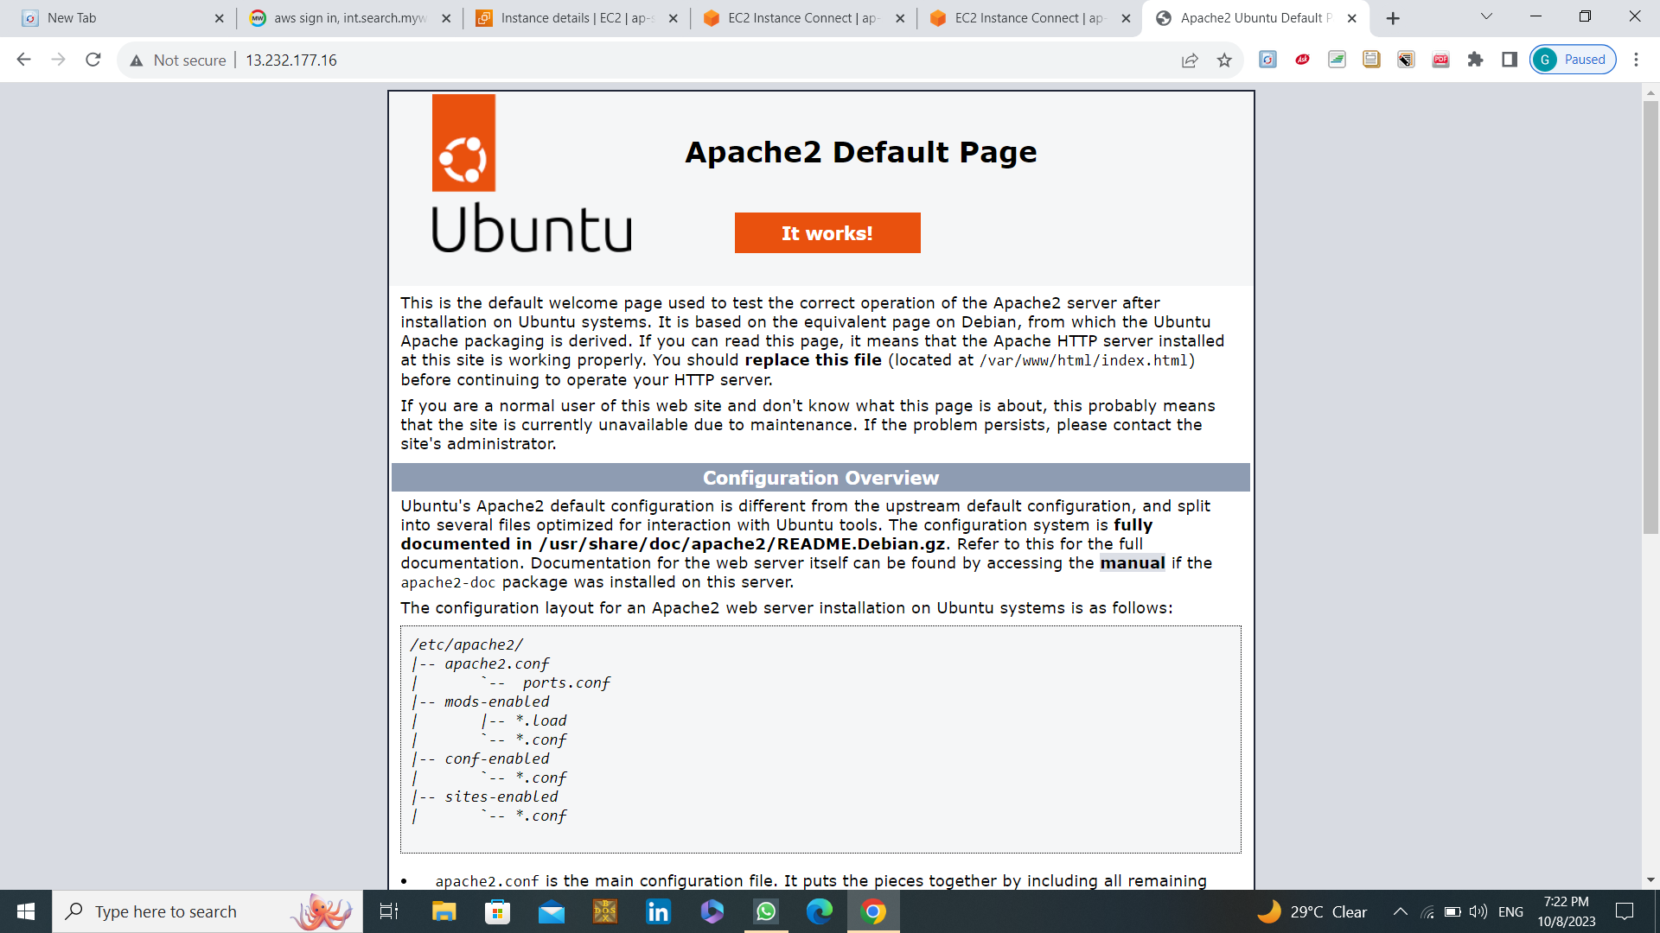

* Now we have to **install php**:

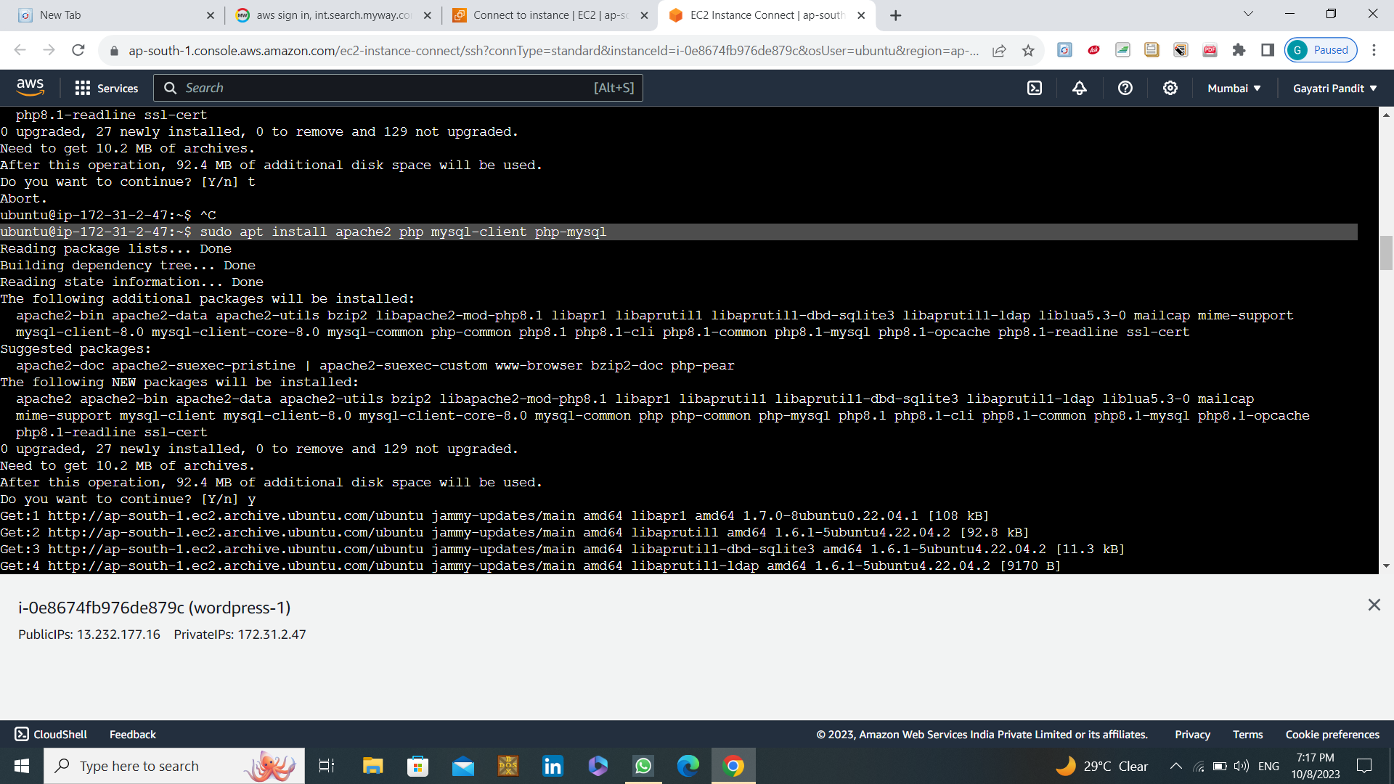

**STEP 3: Install MySQL in EC2- Instance: i.e (mysql-1)**

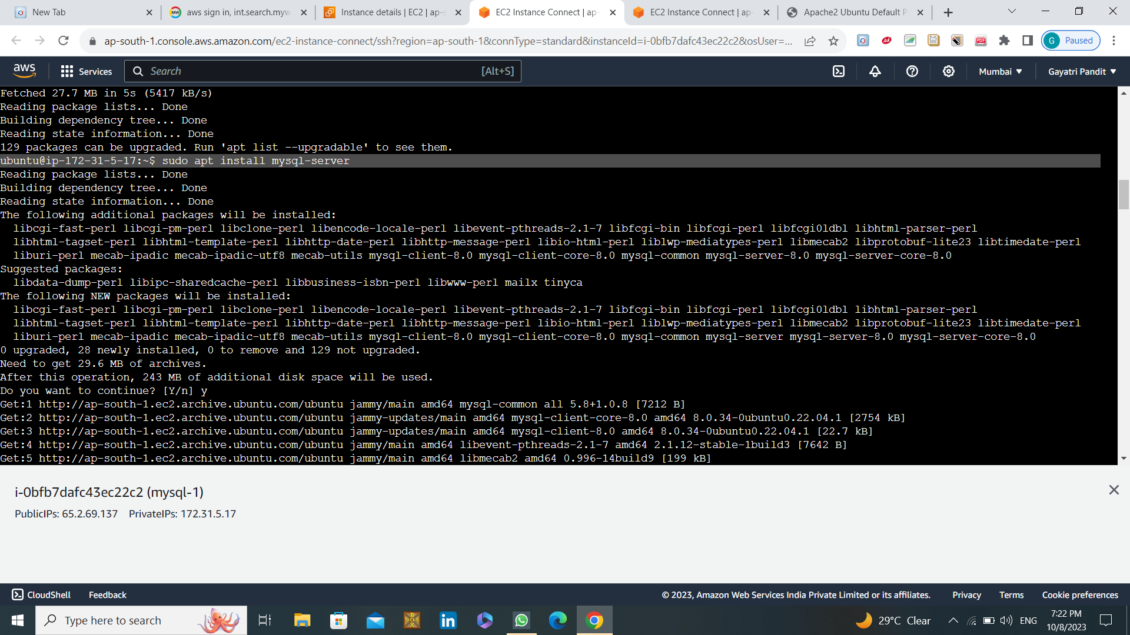

* Creating the database:

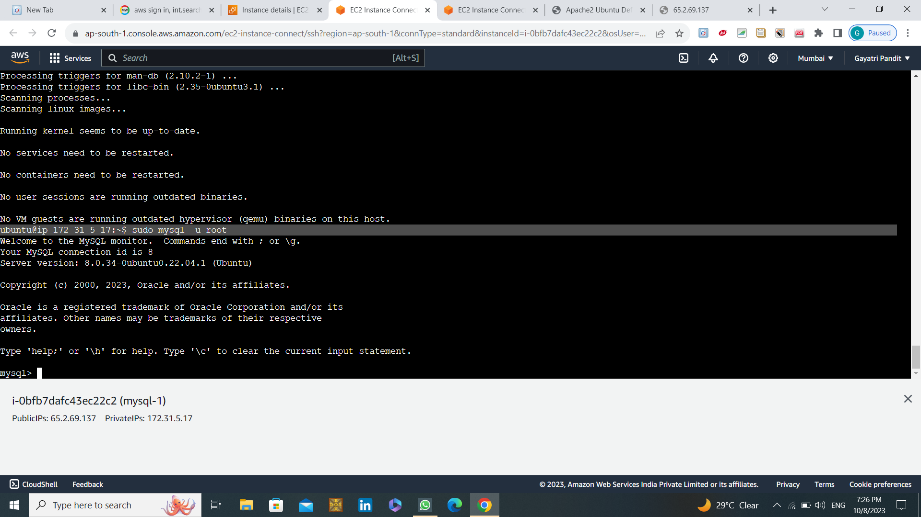

Use commands:

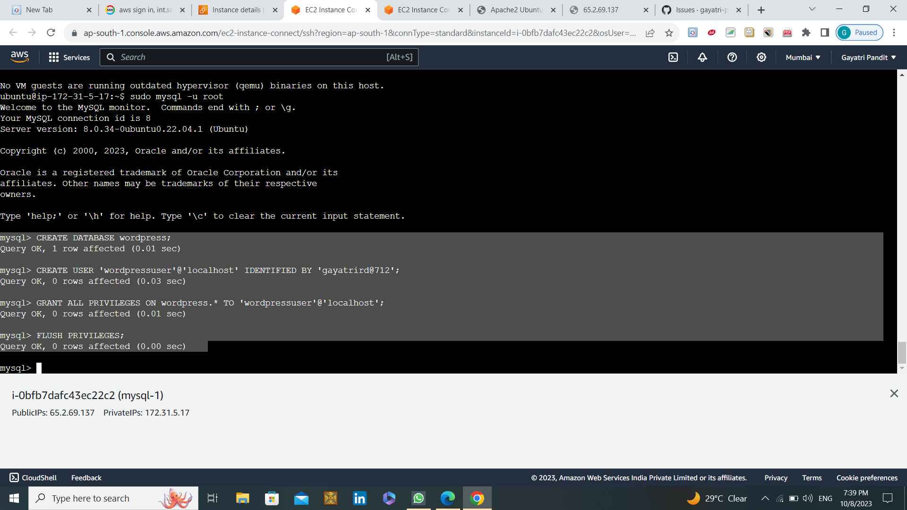

**STEP 4 : Open the terminal of wordpress-1**

* 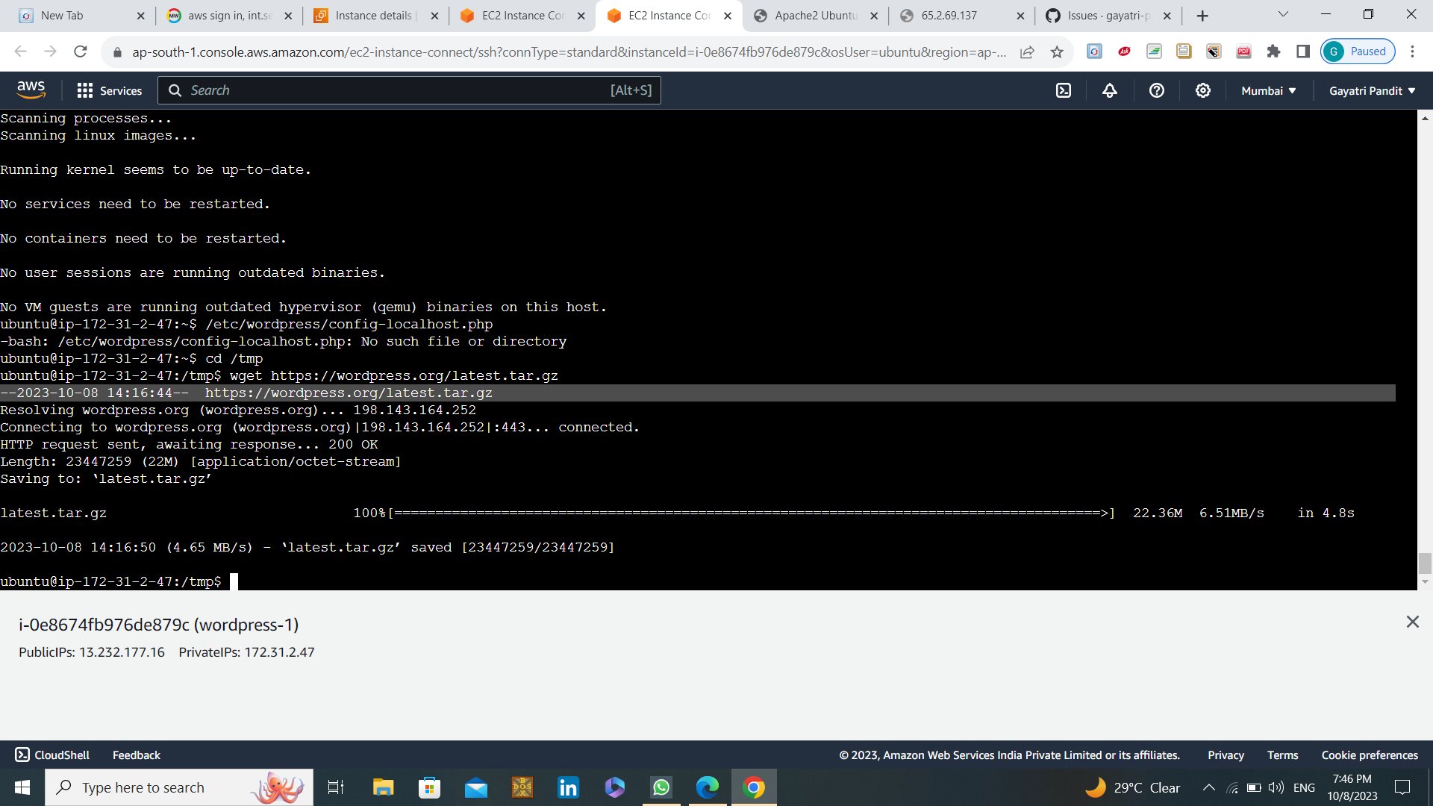Install WordPress:
* Change the permissions of the file:
* Now copy the public IP and browse it. To load the wordPress web page.

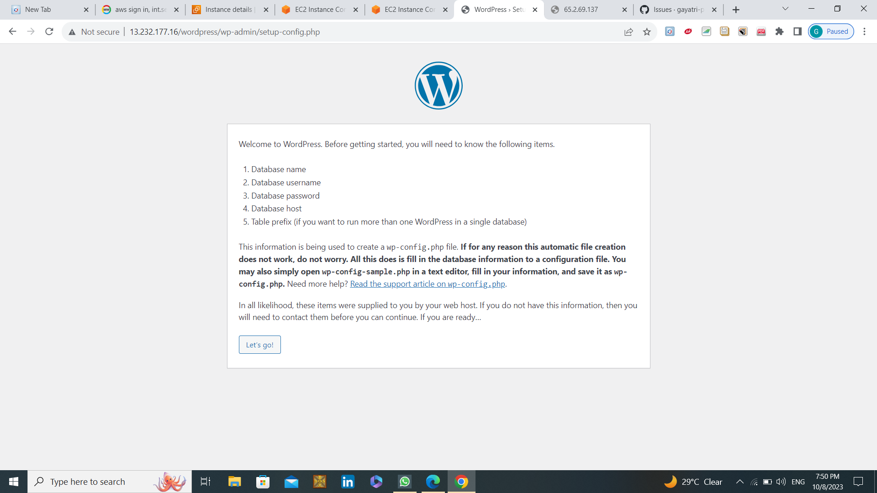

* Click on submit and run it.
* Now WordPress is successfully installed.

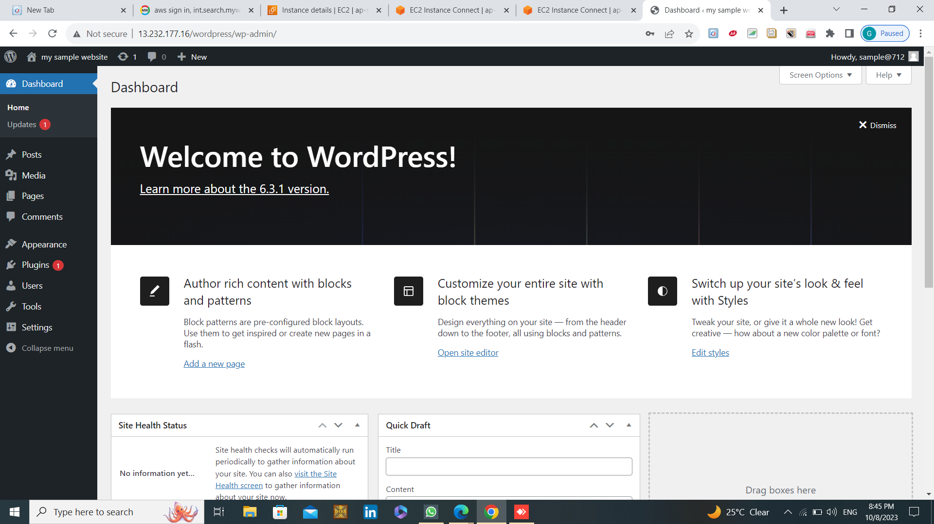

* **Successfully creating a welcome page in WordPress that will be the homepage.**

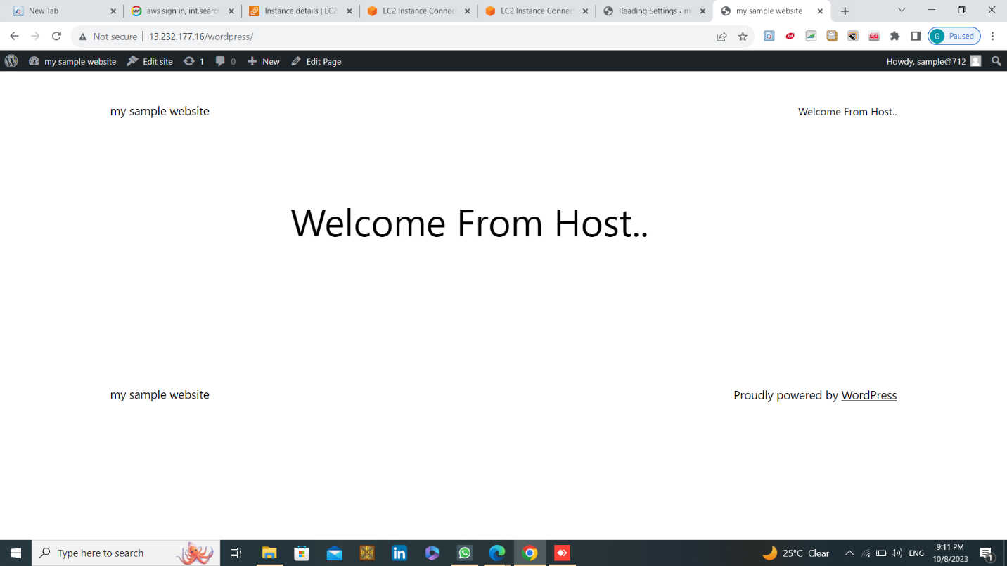

**THANK YOU!**

#infotrixs